Mr. Sabado, Algebra 1 Week 4 Tuesday, February 24, 2015

Home Practice

Due Today:
Assignment #11:
Function Notation review

Due 2/25:
Assignment #12:
Functions

Quiz Friday!!!


Agenda

- Warm-Up
- HW Questions

- Review: Functions

- Class Work: Is it a Function?

- Homework

Warm-Up
Determine if the following is a function. Explain, why or why not?
- 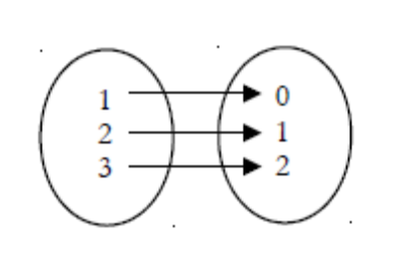
- 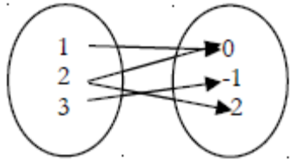
` whs.saba.do


“It is never too late to be what you might have been.”
- G. Eliot

