Mr. Sabado, Algebra 2 Week 6 Friday, March 3, 2016

Home Practice

Due Today:
Assignment #24:
p. 503 (3-27, 64-75)

Due 3/7:
Assignment #25:
p. 504 (28-44, 58, 59)

Quiz on Wednesday (3/8)!!!

Agenda

- Warm-Up
- Turn in Opener Packet

- Lesson: Inverse Properties of Logs

- Class Work

- HW

- Return Graded Work

Warm-Up
Find the inverse of

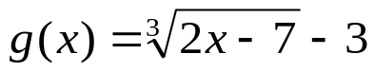

- 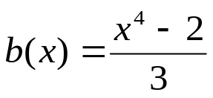



“It is never too late to be what you might have been.”
- G. Eliot

