Mr. Sabado, Alg. 1CD Week 9 Monday, October 19, 2015

Homework

Due Today:
- Assignment #33:
Linear and Exponential Function Practice

Due 10/20:
- Assignment #34:
Exponential Function Practice (blue)

Quiz on Friday!!!

Agenda

- Opener Sheet
- Warm-Up

- Exploration Lesson: Exponential Functions,

- Homework

- Exit Ticket
- Return Graded Work

Warm-Up
Simplify the following when x = 5 and y = -3
- 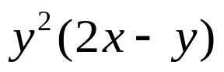
- 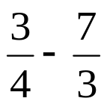
- Simplify
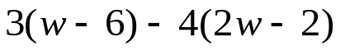


whs.saba.do

“It is never too late to be what you might have been.”
- G. Eliot

0 | 1 | 2 | 3 | 4 | x
 | 2 | 16 | 128

0 | 1 | 2 | 3 |  | X
5 | 2 |  | -4 | -16

