Mr. Sabado, Alg. 1CD Week 9 Thursday, October 22, 2015

Homework

Due Today:
- Assignment #36:
Graphing, Functions, and Solving Review

Due 10/22:
- Assignment #37:
Quiz Review

Quiz on Friday!!!
Unit Test Next Tuesday!

Agenda

- Warm-Up

- Review: Linear and Exponential Functions

- Class Work: Would you rather…

- Homework

- Exit Ticket
- Return Graded Work

Warm-Up
- Solve
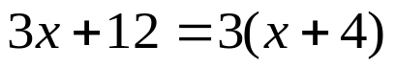

- 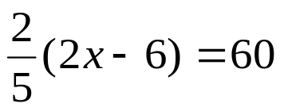

- 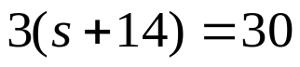


whs.saba.do

“It is never too late to be what you might have been.”
- G. Eliot

