Mr. Sabado, Alg. 1CD Week 9 Friday, October 23, 2015

Homework

Due Today:
- Assignment #37:
Quiz Review

Due 10/26:
- Assignment #38:
Review Worksheet

Quiz on Friday!!!
Unit Test Next Tuesday!

Agenda

- Warm-Up
- Turn in Opener Packet

- Quiz: Linear and Exponential Functions

- Homework

- Return Graded Work

Warm-Up
Solve

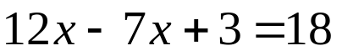

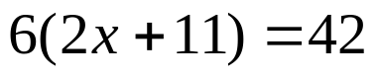


whs.saba.do

“It is never too late to be what you might have been.”
- G. Eliot

