Mr. Sabado, Alg. 1CD Week 10 Monday, October 26, 2015

Homework

Due Today:
- Assignment #38:
Review Worksheet

Due 10/27:
- Assignment #39:
Unit 2 Study Guide

Unit Test on Tuesday!

Agenda

- Warm-Up

- Self-Test: Linear and Exponential Functions

- Homework

- Return Graded Work

Warm-Up
Solve
- 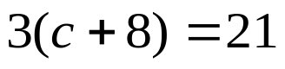

- 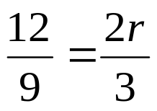


whs.saba.do

“It is never too late to be what you might have been.”
- G. Eliot

