Mr. Sabado, Alg. 1CD Week 10 Thursday, October 29, 2015

Homework

Due Today:
- Assignment #41:
Independent Practice: Exponents and OoO

Due 10/30:
- Assignment #42:
Powers and Exponents Worksheet

Skill Quiz on Friday!
(higher score wins)

Agenda

- Warm-Up
- HW Questions

- Review: Solving Equations, Systems, Linear and Exponential Functions

- Homework

- Return Graded Work

Warm-Up
Solve by elimination
- 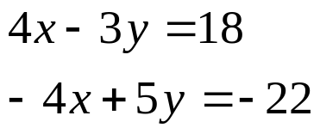

- 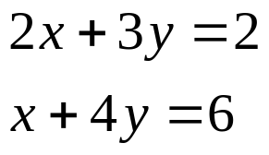

 | 4 | 5 | 6 | 7
y | 80 | 70 | 60 | 50


whs.saba.do

“It is never too late to be what you might have been.”
- G. Eliot

