Mr. Sabado, Alg. 1CD Week 12 Friday, November 13, 2015

Homework

Due Today:
- Assignment #51:
Exponent Review

Due 11/15:
- Assignment #52:
Activity #2 & 3: Expression Review

Skill Quiz on Friday!
(higher score wins)

Unit Test on 11/20!!!

Agenda

- Warm-Up
- HW Questions
- Turn in Opener Packet
- Class Work

- Quiz: Power of a Product and Raising a Quotient to a Power

- Homework

- Return Graded Work

Warm-Up
Simplify, expand if you need to.
1.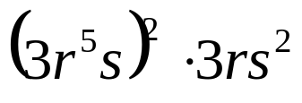
2. 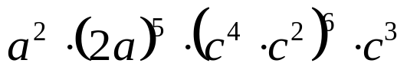
3. 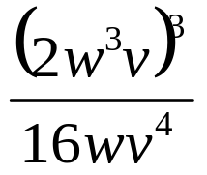




 | 4 | 5 | 6 | 7
y | 80 | 70 | 60 | 50


whs.saba.do

“It is never too late to be what you might have been.”
- G. Eliot

