Mr. Sabado, Alg. 1CD Week 13 Monday, November 16, 2015

Homework

Due Today:
- Assignment #52:
Activity #2 & 3: Expression Review

Due 11/17:
- Assignment #53:
Independent Practice: Zero and Negative Exponents

Unit Test on 11/20!!!

Agenda

- Opener Sheet
- Warm-Up

- Lesson: Zero and Negative Exponents

- Class Work
- Homework

- Return Graded Work

Warm-Up
Simplify, expand if you need to.
1.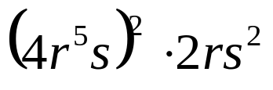
2. 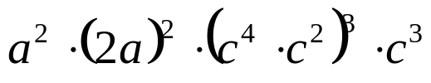
3. 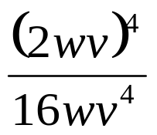




 | 4 | 5 | 6 | 7
y | 80 | 70 | 60 | 50


whs.saba.do

“It is never too late to be what you might have been.”
- G. Eliot

