Mr. Sabado, Math 1CD Week 13 Wednesday, November 18, 2015

Homework

Due Today:
- Assignment #54:
Unfinished Class Work

Due 11/19:
- Assignment #55:
Extra Practice Worksheet p. 21 & 29

Unit Test on 11/20!!!

Agenda

- Warm-Up

- Review: Zero and Negative Exponents

- Class Work
- Homework
- Extra Credit

- Return Graded Work

Warm-Up
Simplify, expand if you need to.
1.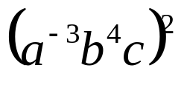
2. 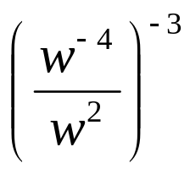




 | 4 | 5 | 6 | 7
y | 80 | 70 | 60 | 50


whs.saba.do

“It is never too late to be what you might have been.”
- G. Eliot

