Mr. Sabado, Alg. 1CD Week 11 Monday, November 2, 2015

Homework

Due Today:
- Assignment #43:
Extra Practice: Exponents and Order of Operations

Due 11/3:
- Assignment #44:
Laws of Powers Part 1

Skill Quiz on Friday!
(higher score wins)

Agenda

- Seating Chart
- Warm-Up

- Lesson: Multiplying Powers

- Class Work

- Homework

- Exit Ticket
- Return Graded Work

Warm-Up
Simplify the following when w = 4 and z = 2
1.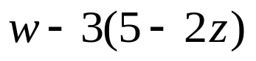

2. 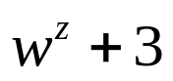

3. 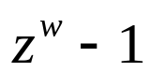



 | 4 | 5 | 6 | 7
y | 80 | 70 | 60 | 50


whs.saba.do

“It is never too late to be what you might have been.”
- G. Eliot

