Mr. Sabado, Math 1CD Week 14 Tuesday, November 24, 2015

Homework

Due Today:
- Assignment #58:
Cumulative Review Worksheet

Due 11/30:
- Assignment #59:
What did people say…

Make-Up Test Today!!!

Agenda
- Turn in Test Corrections

- Warm-Up

- Turn in Turn In Opener Packet

- Class Work: 5 in a Row
- Homework
- Return Graded Work

Warm-Up

Solve
- 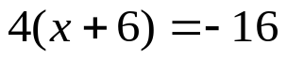

- 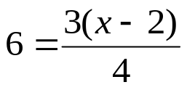




 | 4 | 5 | 6 | 7
y | 80 | 70 | 60 | 50


whs.saba.do

“It is never too late to be what you might have been.”
- G. Eliot

