Mr. Sabado, Alg. 1CD Week 11 Wednesday, November 4, 2015

Homework

Due Today:
- Assignment #45:
Laws of Powers Part 2

Due 11/5:
- Assignment #46:
Simplifying Fractions

Skill Quiz on Friday!
(higher score wins)

Agenda

- Warm-Up

- Review: Dividing Powers

- Class Work

- Homework

- Return Graded Work

Warm-Up
Simplify, expand if you need to.
1.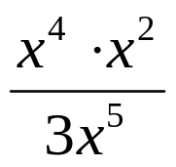

2. 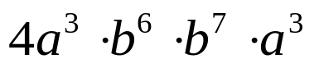

3. 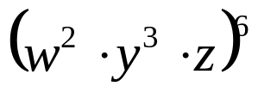



 | 4 | 5 | 6 | 7
y | 80 | 70 | 60 | 50


whs.saba.do

“It is never too late to be what you might have been.”
- G. Eliot

