Mr. Sabado, Alg. 1CD Week 11 Friday, November 6, 2015

Homework

Due Today:
- Assignment #47:
Why Isn’t a Snowman Very Smart?

Due 11/9:
- Assignment #48:
What Do You Call a Bar of Soap…

Skill Quiz on Friday!
(higher score wins)

Agenda

- Warm-Up
- Turn in Opener Packet

- Quiz: Review + Exponents

- Quiet Activity

- Homework

- Return Graded Work

Warm-Up
Simplify, expand if you need to.
1.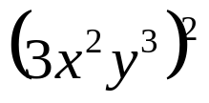

2. 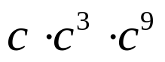

3. 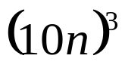




 | 4 | 5 | 6 | 7
y | 80 | 70 | 60 | 50


whs.saba.do

“It is never too late to be what you might have been.”
- G. Eliot

