Mr. Sabado, Alg. 1CD Week 12 Monday, November 9, 2015

Homework

Due Today:
- Assignment #48:
What Do You Call a Bar of Soap…

Due 11/10:
- Assignment #48:
Multiplying Powers

Skill Quiz on Friday!
(higher score wins)

Agenda

- Opener Sheet
- Warm-Up

- Review: Dividing Exponents

- Class Work

- Homework

- Return Graded Work

Warm-Up
Simplify, expand if you need to.
1.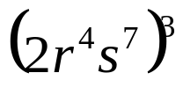

2. 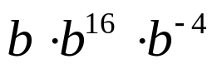

3. 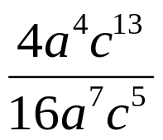


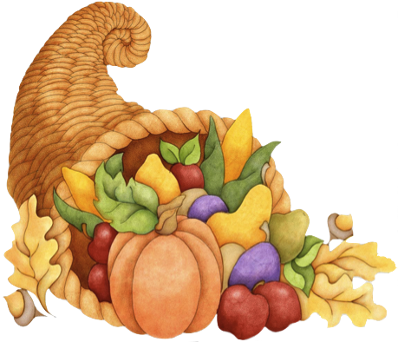

 | 4 | 5 | 6 | 7
y | 80 | 70 | 60 | 50


whs.saba.do

“It is never too late to be what you might have been.”
- G. Eliot

