Mr. Sabado, Math 1CD Week 15 Wednesday, December 2, 2015

Homework

Due Today:
- Assignment #62:
Ind. Practice: Adding & Subtracting Poly

Due 12/3:
- Assignment #63:
Extra Practice: Adding & Subtracting Poly

Skill Quiz on Friday!!!

Agenda

- Warm-Up
- HW Questions

- Lesson: Polynomials

- Class Work

- Homework

- Return Graded Work

Warm-Up

Simplify
1.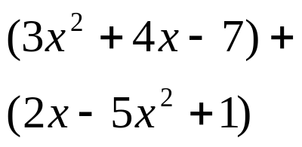

2. 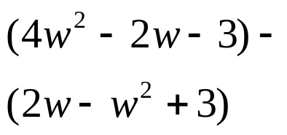

3. 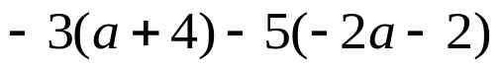


 | 4 | 5 | 6 | 7
y | 80 | 70 | 60 | 50


whs.saba.do

“It is never too late to be what you might have been.”
- G. Eliot

