Mr. Sabado, Algebra 2 Week 10 Wednesday, October 28, 2015

Homework

Due Today:
- Assignment #42
p. 269: 7-33 odd,
and
p. 279: 5-11 odd

Due 10/28:
- Assignment #43
p. 288: 13-27, 35, 50, 53

Quiz on Friday!!!

Agenda

- Warm-Up

- Lesson: Completing the Square

- Class Work

- Homework

- Return Graded Work


Warm-Up

Simplify
- 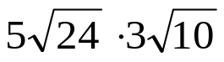

2)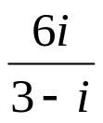

3. 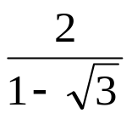

Algebra 2 Online Textbook: 2606518-10
classzone.com

whs.saba.do

yes

“It is never too late to be what you might have been.”
- G. Eliot

