Mr. Sabado, Algebra 2 Week 10 Thursday, October 29, 2015

Homework

Due Today:
- Assignment #43
p. 288: 13-27, 35, 50, 53

Due 10/29:
- Assignment #44
Quiz Review Worksheet

Quiz on Friday!!!


Agenda

- Warm-Up
- HW Questions

- Quiz Review: Factoring, Solving, Imaginary #s, Completing the Sq.

- Class Work: Speed Dating

- Homework
- Exit Ticket

Warm-Up

Simplify
- 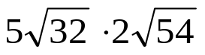

2)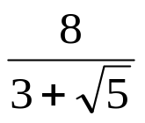
Solve by completing the square
3. 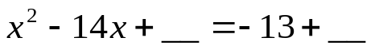

Algebra 2 Online Textbook: 2606518-10
classzone.com

whs.saba.do

yes

“It is never too late to be what you might have been.”
- G. Eliot

