Mr. Sabado, Algebra 2 Week 10 Friday, October 30, 2015

Homework

Due Today:
- Assignment #44
Quiz Review Worksheet

Due 11/2:
- Assignment #45
p. 288: 9-12, 28-34, 37, 51, 55, 69-74

Quiz on Friday!!!


Agenda

- Warm-Up
- Turn in Opener Packet

- Quiz: Factoring, Solving, Imaginary #s, Completing the Square

- Quiet Activity

- Homework

Warm-Up

Simplify
- 

2)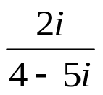
Solve by factoring
3. 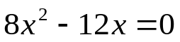

Algebra 2 Online Textbook: 2606518-10
classzone.com
whs.saba.do

yes

“It is never too late to be what you might have been.”
- G. Eliot

