Mr. Sabado, Algebra 2 Week 13 Friday, November 20, 2015

Homework
Due Today:
- Assignment #58
p. 304: (3-23 odd, 18)

Due 11/23:
- Assignment #59
p. 312: (4-9, 15-17, 19-27 odd, 26)

Graphing Test on Tuesday (11/24)


Agenda

- Warm-Up
- Turn in Packet

- Lesson: Writing Quadratic Equations

- Class Work

- Homework

- Return Graded Work

Warm-Up
Solve using any method.
- 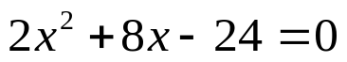
- 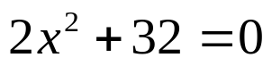

- 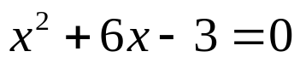
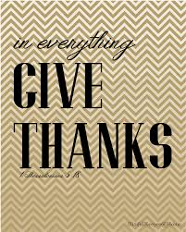

yes

“It is never too late to be what you might have been.”
- G. Eliot

