Mr. Sabado, Algebra 2 Week 14 Monday, November 23, 2015

Homework
Due Today:
- Assignment #59
p. 312: (4-9, 15-17, 19-27 odd, 26)

Due 11/24:
- Assignment #60
Graphing Review (white)
- Assignment #61
Graphing Review (yellow)

Graphing Test on Tuesday (11/24)


Agenda

- Opener Sheet
- Warm-Up

- Unit 3 Test: Solving – Test Corrections

- Class Work

- Homework

- Return Graded Work

Warm-Up
Simplify

- 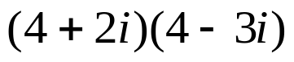
- 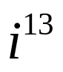



yes

“It is never too late to be what you might have been.”
- G. Eliot

