Mr. Sabado, Algebra 2 Week 11 Thursday, November 5, 2015

Homework

Due Today:
- Assignment #48
4.8 Practice A Worksheet (1-41 odd)

Due 11/6:
- Assignment #49
Review Worksheet

Unit Test Next Friday (11/13)

Agenda

- Warm-Up

- Review: Solving, Imaginary, and Discriminant

- Class Work
- Homework

- Exit Ticket
- Return Graded Work

Warm-Up

Solve
- 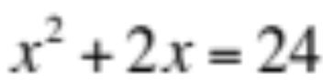

2. 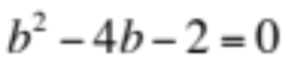

3. Simplify
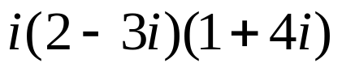

Algebra 2 Online Textbook: 2606518-10
classzone.com
whs.saba.do

yes

“It is never too late to be what you might have been.”
- G. Eliot


