Mr. Sabado, Algebra 2 Week 15 Friday, December 4, 2015

Homework

Due Today:
- Assignment #66
p. 356: (3-17, 30-33, 51)

Due 12/7:
- Assignment #66
p. 357: (18-29, 36-41, 45-50, 61, 62)

Quiz Today!!! (Section 5.2-5.4)



Agenda

- Warm-Up
- Turn in Opener Packet

- Quiz: Factoring Polynomials

- Homework

- Return Graded Work

Warm-Up

Factor Completely
- 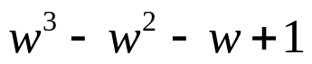

Multiply
- 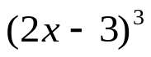



yes

“It is never too late to be what you might have been.”
- G. Eliot

