Mr. Sabado, Algebra 2 Week 5 Monday, September 21, 2015

Homework

Due Today:
- Assignment #18: Unit Review 1

Due 9/22:
- Assignment #19: Unit Review 2

Unit Test on Tuesday!!! (9/22)

Agenda

- Warm-Up
- New Opener Sheet

- Review Class Work: Functions

- Return Graded Work

- Homework

Warm-Up

- Graph the following function:

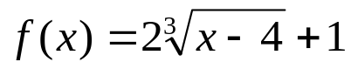

State the following:
2. Domain & Range
3. End behavior
4. Intervals of increase & decrease.

whs.saba.do



“It is never too late to be what you might have been.”
- G. Eliot

