Mr. Sabado, Algebra 1 Week 15 Monday, December 8, 2014

Homework

Due Today:
- Assignment #57:
- Activity 31 Worksheet

Due 12/9:
- Assignment #58:
- Solving Equations pg. 38

Test on Thursday and Friday!!!


Agenda

- Pick Up Opener Sheet
- Warm-Up
- HW Questions

- Review: Solving Equations

- Class Work
- Homework

- Return Graded Work

Warm-Up

Solve
- 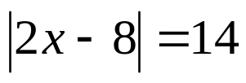

- 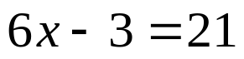

- 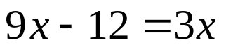


whs.saba.do

“It is never too late to be what you might have been.”
- G. Eliot

