Mr. Sabado, Algebra 1 Week 2 Tuesday, February 10, 2015

Home Practice

Due Today:
Assignment #4:
Simplifying Expressions

Due 2/11:
Assignment #5:
4-2 Relations and Functions



Agenda

- Warm-Up
- HW Questions

- Lesson: Function Box

- Class Work:

- Homework

Warm-Up

Solve
- 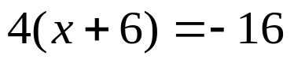

- 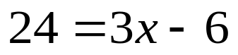

`whs.saba.do

“It is never too late to be what you might have been.”
- G. Eliot

