Mr. Sabado, Algebra 1 Week 2 Wednesday, February 11, 2015

Home Practice

Due Today:
Assignment #5:
4-2 Relations and Functions pg. 13

Due 2/12:
Assignment #6:
p. 209 #2-14

Quiz on Friday!!!



Agenda

- Warm-Up
- HW Questions

- Lesson Continued: Function Box

- Class Work:

- Homework

Warm-Up

Graph the following and determine if it is a function (is there is a pattern?)

- (-5, 3), (-2, 1), (1, -1), (4, -3)

Simplify
- 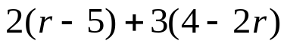

`whs.saba.do

“It is never too late to be what you might have been.”
- G. Eliot

