Mr. Sabado, Algebra 1 Week 2 Thursday, February 12, 2015

Home Practice

Due Today:
Assignment #6:
p. 209 #2-14

Due 2/13:
Assignment #7:
Relations and Functions Worksheet (Practice C)

Quiz on Friday!!!



Agenda

- Warm-Up
- HW Questions

- Quiz Review: Order of Operations, Fractions, Distributive Property, Functions

- Class Work:

- Homework

Warm-Up

Simplify the following when x = 5 and y = -3
- 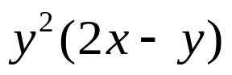
- 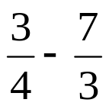
- Simplify
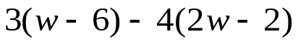

`whs.saba.do

“It is never too late to be what you might have been.”
- G. Eliot

