Mr. Sabado, Algebra 2 Week 2 Wednesday, February 11, 2015

Home Practice

Due Today:
Assignment #5:
p. 577 #6-42 mult. of 3, 19

Due 2/12:
Assignment #6:
What did Klorine say… Worksheet



Agenda

- Warm-Up
- HW Questions

- Lesson: Add & Subtract Rational Expressions

- Clock Buddy Class Work

- Homework

Warm-Up

Simplify

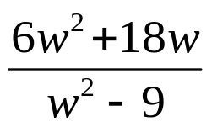

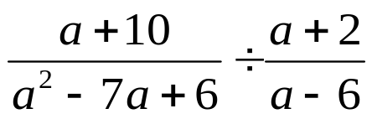
`whs.saba.do

“It is never too late to be what you might have been.”
- G. Eliot

