Mr. Sabado, Algebra 2 Week 2 Thursday, February 12, 2015

Home Practice

Due Today:
Assignment #6:
What did Klorine say… Worksheet

Due 2/13:
Assignment #7:
p. 587 #31-36, 46-54

Quiz on Friday!!!

Agenda

- Warm-Up
- HW Questions

- Lesson: Complex Rational Expressions

- Class Work

- Homework


Warm-Up

Simplify

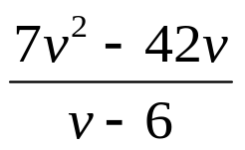

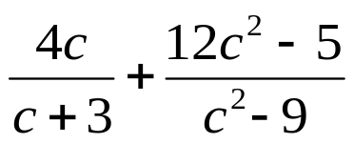
`whs.saba.do

“It is never too late to be what you might have been.”
- G. Eliot

