Mr. Sabado, Algebra 2 Week 15 Monday, May 11, 2015

Home Practice

Due Today:
Assignment #52:
p. 747: 3-10, 27

Due 5/12:
Assignment #53:
- Page 753: 3, 7, 9, 11, 18, 20, 21, 26-29

Quiz on Wednesday!!! (Sections 11.1-11.2)



Agenda

- Seating Chart
- Warm-Up

- Lesson: Transformations to Data

- Class Work

- Homework

- Return Graded Work

Warm-Up

Using the following list:
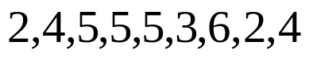

Determine the
- Range
- Mean
- Standard Deviation

`whs.saba.do


+

If

“It is never too late to be what you might have been.”
- G. Eliot

p.686 (3-10, 11-296 odd, 56, 62-65

