Mr. Sabado, Algebra 2 Week 15 Tuesday, May 12, 2015

Home Practice

Due Today:
Assignment #53:
- Page 753: 3, 7, 9, 11, 18, 20, 21, 26-29

Due 5/13:
Assignment #54:
- Page 756: 1-6

Quiz on Wednesday!!! (Sections 11.1-11.2)



Agenda

- Warm-Up

- Lesson: Statistics Review

- Class Work

- Homework

- Return Graded Work

Warm-Up

Evaluate
- 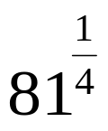

Find the Inverse
- 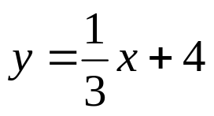
Solve
- 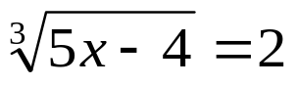

`whs.saba.do


+

If

“It is never too late to be what you might have been.”
- G. Eliot

p.686 (3-10, 11-296 odd, 56, 62-65

