Mr. Sabado, Algebra 2 Week 15 Thursday, May 14, 2015

Home Practice

Due Today:
Assignment #55:
- Page 760: 9-18, 32, 41-53 odd

Due 5/15:
Assignment #56:
- Statistics Packet: 8.1



Agenda

- Warm-Up

- Lesson: Normal Curves, Standard Deviation

- Classwork: Is it Normal?

- Homework

- Return Graded Work

Warm-Up

Find the inverse of

- 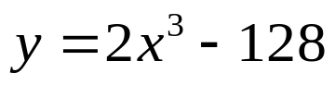
- 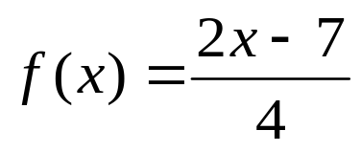

`whs.saba.do


+

If

“It is never too late to be what you might have been.”
- G. Eliot

p.686 (3-10, 11-296 odd, 56, 62-65

