Mr. Sabado, Algebra 2 Week 16 Tuesday, May 19, 2015

Home Practice

Due Today:
Assignment #58:
Normal Curve Review

Due 5/20:
Assignment #59:
p. 769: 1-5, 28, 33-38



Agenda

- Warm-Up

- Lesson: Types of Studies,
Bias and Unbias

- Classwork

- Homework

- Return Graded Work

Warm-Up

Evaluate the following

- 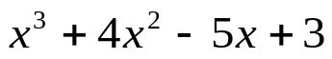 when x = - 3

- 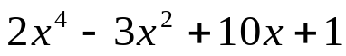 when x = 2

`whs.saba.do


+

If

“It is never too late to be what you might have been.”
- G. Eliot

