Mr. Sabado, Algebra 2 Week 16 Wednesday, May 20, 2015

Home Practice

Due Today:
Assignment #59:
p. 769: 1-5, 28, 33-38

Due 5/21:
Assignment #60:
Types of Studies


Agenda

- Warm-Up

- Lesson: Types of Studies,
Bias and Unbias

- Classwork

- Homework

- Return Graded Work

Warm-Up

Simplify

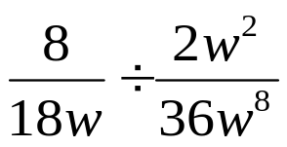

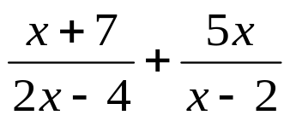
`whs.saba.do

+

If

“It is never too late to be what you might have been.”
- G. Eliot

