Mr. Sabado, Algebra 2 Week 16 Friday, May 22, 2015

Home Practice

Due Today:
Assignment #61:
p.770: 6-25, 27, 29, 30

Due 5/26:
Assignment #62:
Normal Distribution Review


Agenda

- Warm-Up
Finish Packet
- Turn in Opener Packet

- Homework

- Return Graded Work

Warm-Up

Simplify

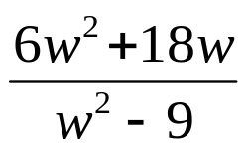

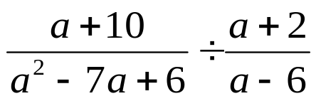
`whs.saba.do

+

If

“It is never too late to be what you might have been.”
- G. Eliot

