Mr. Sabado, Algebra 2 Week 17 Wednesday, May 27, 2015

Home Practice

Due Today:
Assignment #62:
Normal Distribution Review
Due 5/29:
Assignment #63:
Do You Fit?
Assignment #64:
Using Sampling and Simulations

Quiz on Friday!!!


Agenda

- Opener Sheet
- Warm-Up

- Lesson: Simulations

- Class Work

- Homework

- Return Graded Work

Warm-Up

Evaluate the logs
1) 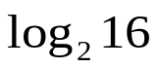
2) 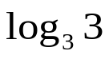
3) 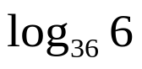
`whs.saba.do

+

If

“It is never too late to be what you might have been.”
- G. Eliot

