Mr. Sabado, Algebra 2 Week 14 Friday, May 8, 2015

Home Practice

Due Today:
Assignment #51:
p. 678: 1-14, 16-27, 31-33, 46, 48

Due 5/11:
Assignment #52:
p. 747: 3-10, 27



Agenda

- Warm-Up

- Lesson: Central Tendency and Dispersion

- Class Work

- Homework
- Turn in Opener Packet

- Return Graded Work

Warm-Up

Using the following list:
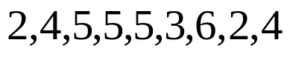

Determine the
a) Mean
b) Median
c) Mode

`whs.saba.do


+

If

“It is never too late to be what you might have been.”
- G. Eliot

p.686 (3-10, 11-296 odd, 56, 62-65

