Mr. Sabado, Alg. 1CD Week 4 Tuesday, September 15, 2015

Homework

Due Today:
- Assignment #12:
Solve each system…
Page 14 & 15 (white)

Due 9/16:
- Assignment #13:
Solving by Substitution (blue)

Quiz Friday!!!

Agenda

- Warm-Up
- HW Questions

- Review: Solving Systems by Substitution + Review

- Class Work

- Return Graded Work
l

Warm-Up

Solve the following by substitution:
- 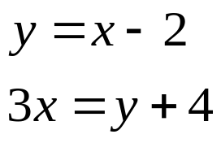
- 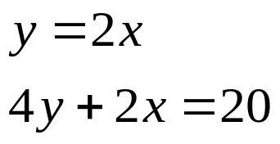

whs.saba.do



“It is never too late to be what you might have been.”
- G. Eliot

