Mr. Sabado, Algebra 2 Week 4 Thursday, September 17, 2015

Homework

Due Today:
- Assignment #16: Piecewise Functions

Due 9/18:
- Assignment #17: Writing Functions

Unit Test on Tuesday!!! (9/22)

Agenda

- Warm-Up
- HW Questions

- Review: Piecewise Functions

- Class Work: Describe a Graph

- Homework

Warm-Up

1.Graph the following piecewise function:

f(x) =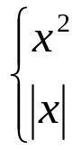 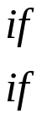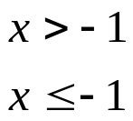

2. Evaluate
f(x) = -3

whs.saba.do



“It is never too late to be what you might have been.”
- G. Eliot

