Mr. Sabado, Algebra 2 Week 2 Monday, August 29, 2015

Homework

Due Today:
- Assignment #4: Scavenger Hunt

Due 8/30:
- Assignment #5: Functions

Algebra 2 Online Textbook: 2606518-10
classzone.com

Agenda

- Warm-Up
- Opener Sheet Expectations

- Lesson: Functions

- Class Work

- Homework
- Practice Dismissal

Warm-Up

Evaluate for x = 2, y = -3, and z = 5
- 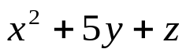
- 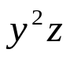

Find the area of the rectangle.
3. 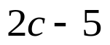
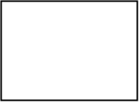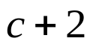

whs.saba.do



“It is never too late to be what you might have been.”
- G. Eliot

