Mr. Sabado, Algebra 2 Week 3 Monday, September 6, 2016

Homework

Due Today:
- Assignment #9: Transformation Review

Due 9/7:
- Assignment #10: Function Families (add D, R, and Int. to each graph)
Algebra 2 Online Textbook: 2606518-10
classzone.com

Agenda

- Warm-Up
- HW Questions

- Lesson: Domain, Range, and Intercepts

- Class Work

- Exit Ticket

Warm-Up
Graph the parent and the transformation:
- 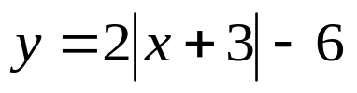

2. 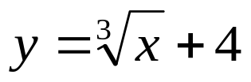

whs.saba.do



Reminder: The bell does not dismiss you, I dismiss you.
- Mr. Sabado

