Mr. Sabado, Algebra 1 Week 4 Tuesday, September 23, 2014

Homework

Due Today:
- Assignment #12:
Page 17: 13-23, 28-34 even, 37-47

Due 9/24:
- Assignment #13:
Page 12&13 Review Worksheet

Bring your Textbook every day!!!
Quiz Friday!!!

Agenda

- Warm-Up

- Review: Party or War

- Classwork

- Field Trip

- Return Quiz


Warm-Up

Determine if the following is a party or war. Then simplify
- 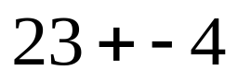

- 

- 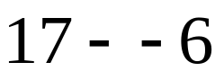

whs.saba.do

“It is never too late to be what you might have been.”
- G. Eliot

