Mr. Sabado, Algebra 1 Week 4 Wednesday, September 24, 2014

Homework

Due Today:
- Assignment #13:
Page 12&13 Review Worksheet

Due 9/25:
- Assignment #14:
Page 23: 14-25, 35-46, 76-78

Bring your Textbook every day!!!
Quiz Friday!!!

Agenda

- Warm-Up

- Lesson: Multiplication and Division

- Math Sprint

- Homework



Warm-Up

Determine if the following is a party or war. Then simplify
- 

- 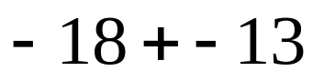

- 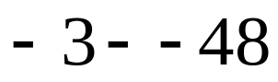

whs.saba.do

“It is never too late to be what you might have been.”
- G. Eliot

