Mr. Sabado, Algebra 1 Week 3 Wednesday, February 18, 2015

Home Practice

Due Today:
Assignment #8:
Evaluating Functions Worksheet

Due 2/19:
Assignment #9:
Finish the Function Notation Packet #3-6
Quiz Friday!!!


Agenda

- Seating Chart Warm-Up

- Lesson Continued: Function Notation

- Class Work

- Homework

Warm-Up

Simplify the following 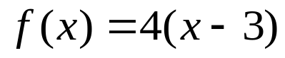
- 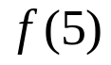
- 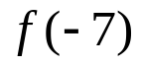
- 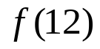`
whs.saba.do


“It is never too late to be what you might have been.”
- G. Eliot

