Mr. Sabado, Algebra 1 Week 3 Thursday, February 19, 2015

Home Practice

Due Today:
Assignment #9:
Function Notation Packet #3-6

Due 2/20:
Assignment #10:
Skills Quiz Study Guide
Quiz Friday!!!


Agenda

- Warm-Up
- HW Questions

- Lesson Continued: Function Notation

- Class Work

- Homework

Warm-Up

Simplify the following 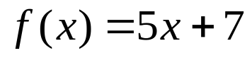
- 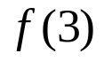
Find the value for x
- 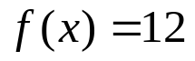
- 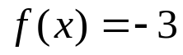`
whs.saba.do


“It is never too late to be what you might have been.”
- G. Eliot

