Mr. Sabado, Algebra 1 Week 3 Friday, February 20, 2015

Home Practice

Due Today:
Assignment #10:
Skills Quiz Study Guide

Due 2/23:
Extra Credit:
This Puzzle is Alarming

Quiz Friday!!!


Agenda

- Warm-Up
- HW Questions
- Turn in Packet

- Skills Quiz #3: Function Notation

- Quiet Activity

- Class Work

Warm-Up
Simplify the following 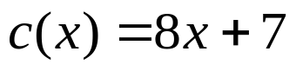
- 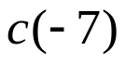
Find the value for x
- 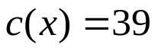
- 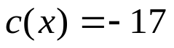` whs.saba.do


“It is never too late to be what you might have been.”
- G. Eliot

