Mr. Sabado, Algebra 2 Week 3 Wednesday, February 18, 2015

Home Practice

Due Today:
Assignment #9:
p. 586 #16-30

Due 2/19:
Assignment #10:
p. 593 #4-13, 33, 34, 45-52



Agenda

- Seating Chart
- Warm-Up

- Lesson: Solve Rational Expressions

- Class Work

- Homework


Warm-Up

Simplify
1. 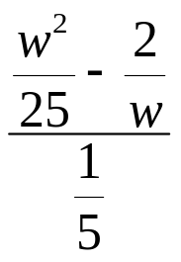
Simplify
2. 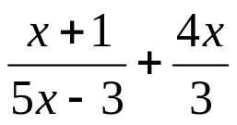
`whs.saba.do

“It is never too late to be what you might have been.”
- G. Eliot

