Mr. Sabado, Algebra 2 Week 3 Friday, February 20, 2015

Home Practice

Due Today:
Assignment #11:
p. 593 #5-19 odd, 26, 28, 30-32, 39-42, 44

Due 2/23:
Assignment #12:
What do you call…
And
What Law Firm… Worksheet

Rational Unit Test on Wednesday (2/25)


Agenda

- Warm-Up
- HW Questions
- Turn in Packet

- Review: Solve Rational Expressions

- Class Work: Clock Buddy Math Sprint

- Homework

Warm-Up

- Simplify
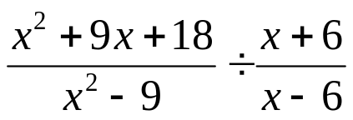

- Solve
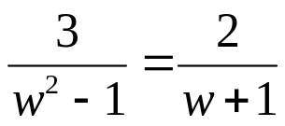
`whs.saba.do


“It is never too late to be what you might have been.”
- G. Eliot
Kaylee and tiffany are awesome ☺

