Mr. Sabado, Algebra 1 Week 19 Thursday, January 22, 2015

Homework

Due Today:
Extra Credit: Why did the Quiz Show…

Due 1/23:
Assignment #74:
Chapter 1 Final Review
Opener Packet

Agenda

- Warm-Up
- HW Questions

- Class Work

- Homework

- Return Graded Work

Warm-Up

1. Simplify
- 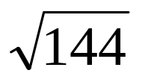

- 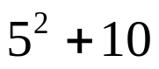

- 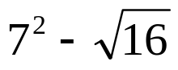

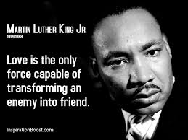
`whs.saba.do

“It is never too late to be what you might have been.”
- G. Eliot

